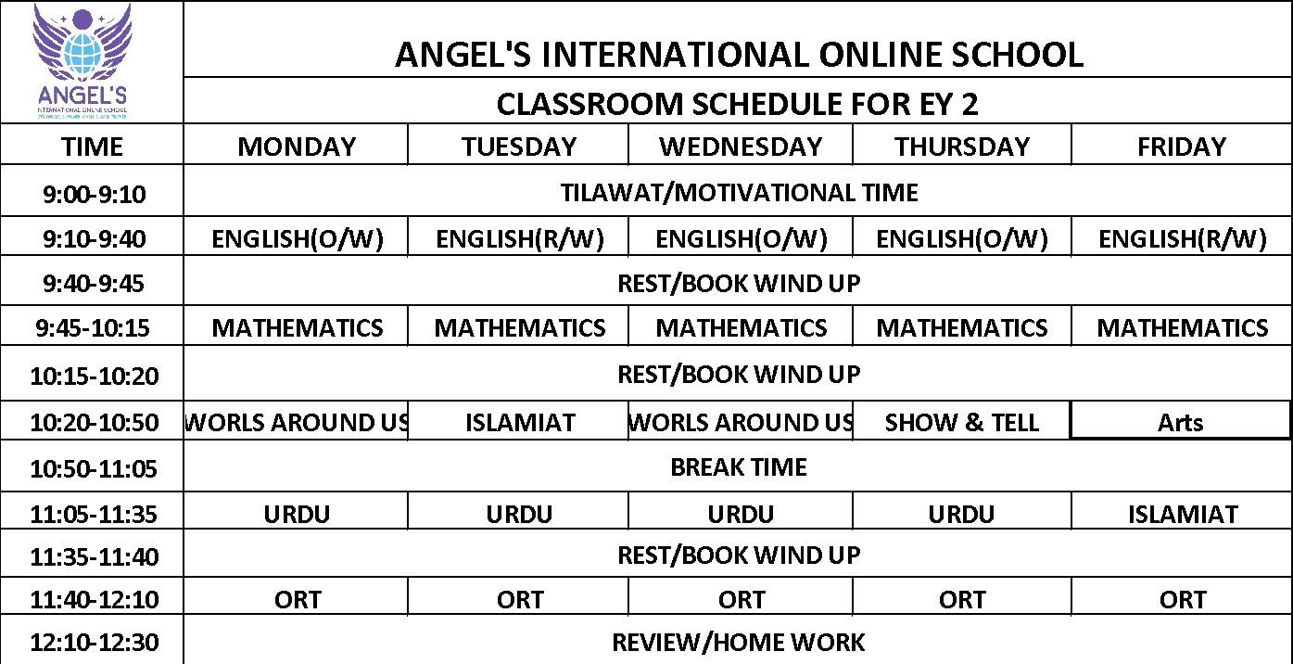

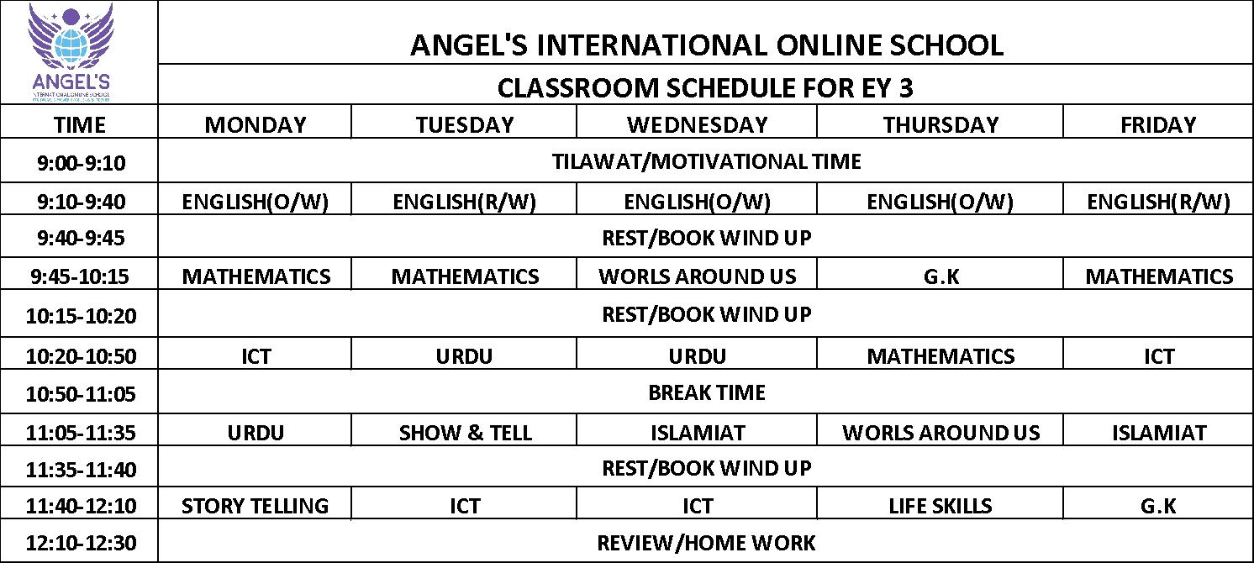

 | ANGEL'S INTERNATIONAL ONLINE SCHOOL
 | CLASSROOM SCHEDULE FOR GRADE I
TIME | MONDAY | TUESDAY | WEDNESDAY | THURSDAY | FRIDAY
9:00-9:10 | TILAWAT/MOTIVATIONAL TIME
9:10-9:40 | ENGLISh | ENGLISH | ENGLISH | ENGLISH | ENGLISH
9:40-10:10 | SCIENCE | SCIENCE | SCIENCE | SCIENCE | MATHEMATICS
10:10-10:40 | ISLAMIAT | GLOBAL PERSPECTIVE | GLOBAL PERSPECTIVE | GLOBAL PERSPECTIVE | ARTS & CRAFTS
10:40-11:00 | BREAK TIME
11:00-11:30 | ICT | ICT | ICT | ICT | URDU
11:30-12:00 | MATHEMATICS | MATHEMATICS | MATHEMATICS | MATHEMATICS | ENTERPRENEURSHIP
12:00-12:25 | URDU | URDU | ISLAMIAT | ISLAMIAT | ENTERPRENEURSHIP
12:25-12:30 | REVIEW/HOME WORK

 | ANGEL'S INTERNATIONAL ONLINE SCHOOL
 | CLASSROOM SCHEDULE FOR GRADE III
TIME | MONDAY | TUESDAY | WEDNESDAY | THURSDAY | FRIDAY
9:00-9:10 | TILAWAT/MOTIVATIONAL TIME
9:10-9:40 | ICT | ICT | ENGLISH | ICT | ICT
9:40-10:10 | ENGLISH | ENGLISH | SCIENCE | ENGLISH | ENGLISH
10:10-10:40 | ISLAMIAT | GLOBAL PERSPECTIVE | GLOBAL PERSPECTIVE | ISLAMIAT | ARTS & CRAFTS
10:40-11:00 | BREAK TIME
11:00-11:30 | MATHEMATICS | MATHEMATICS | MATHEMATICS | MATHEMATICS | MATHEMATICS
11:30-12:00 | URDU | URDU | URDU | GLOBAL PERSPECTIVE | ENTERPRENEURSHIP
12:00-12:25 | SCIENCE | SCIENCE | ISLAMIAT | SCIENCE | ENTERPRENEURSHIP
12:25-12:30 | REVIEW/HOME WORK

 | ANGEL'S INTERNATIONAL ONLINE SCHOOL
 | CLASSROOM SCHEDULE FOR GRADE IV
TIME | MONDAY | TUESDAY | WEDNESDAY | THURSDAY | FRIDAY
9:00-9:10 | TILAWAT/MOTIVATIONAL TIME
9:10-9:40 | ENGLISh | ENGLISH | ICT | ENGLISH | ENGLISH
9:40-10:10 | SCIENCE | SCIENCE | ENGLISH | SCIENCE | ICT
10:10-10:40 | ISLAMIAT | GLOBAL PERSPECTIVE | GLOBAL PERSPECTIVE | GLOBAL PERSPECTIVE | ARTS & CRAFTS
10:40-11:00 | BREAK TIME
11:00-11:30 | MATHEMATICS | MATHEMATICS | MATHEMATICS | MATHEMATICS | MATHEMATICS
11:30-12:00 | URDU | URDU | URDU | ICT | ENTERPRENEURSHIP
12:00-12:25 | ICT | ISLAMIAT | SCIENCE | ISLAMIAT | ENTERPRENEURSHIP
12:25-12:30 | REVIEW/HOME WORK

 | ANGEL'S INTERNATIONAL ONLINE SCHOOL
 | CLASSROOM SCHEDULE FOR GRADE V
TIME | MONDAY | TUESDAY | WEDNESDAY | THURSDAY | FRIDAY
9:00-9:10 | TILAWAT/MOTIVATIONAL TIME
9:10-9:40 | MATHEMATICS | MATHEMATICS | MATHEMATICS | MATHEMATICS | MATHEMATICS
9:40-10:10 | ISLAMIAT | URDU | ISLAMIAT | ISLAMIAT | ARTS & CRAFTS
10:10-10:40 | URDU | ICT | ICT | ICT | ENGLISH
10:40-11:00 | BREAK TIME
11:00-11:30 | SCIENCE | SCIENCE | SCIENCE | SCIENCE | ICT
11:30-12:00 | ENGLISH | ENGLISH | ENGLISH | ENGLISH | ENTERPRENEURSHIP
12:00-12:25 | GLOBAL PERSPECTIVE | GLOBAL PERSPECTIVE | GLOBAL PERSPECTIVE | URDU | ENTERPRENEURSHIP
12:25-12:30 | REVIEW/HOME WORK

 | ANGEL'S INTERNATIONAL ONLINE SCHOOL
 | CLASSROOM SCHEDULE FOR GRADE VI
TIME | MONDAY | TUESDAY | WEDNESDAY | THURSDAY | FRIDAY
9:00-9:10 | TILAWAT/MOTIVATIONAL TIME
9:10-9:40 | ENGLISH | ENGLISH | ENGLISH | ENGLISH | ENGLISH
9:40-10:10 | GEOGRAPHY | URDU | URDU | GEOGRAPHY | ARTS & CRAFTS
10:10-10:40 | URDU | ISLAMIAT | ISLAMIAT | ISLAMIAT | SCIENCE
10:40-11:00 | BREAK TIME
11:00-11:30 | MATHEMATICS | MATHEMATICS | MATHEMATICS | MATHEMATICS | MATHEMATICS
11:30-12:00 | COMP.SCI | COMP.SCI | COMP.SCI | COMP.SCI | ENTERPRENEURSHIP
12:00-12:25 | SCIENCE | SCIENCE | SCIENCE | HISTORY | ENTERPRENEURSHIP
12:25-12:30 | REVIEW/HOME WORK

 | ANGEL'S INTERNATIONAL ONLINE SCHOOL
 | CLASSROOM SCHEDULE FOR GRADE Vll
TIME | MONDAY | TUESDAY | WEDNESDAY | THURSDAY | FRIDAY
9:00-9:10 | TILAWAT/MOTIVATIONAL TIME
9:10-9:40 | SCIENCE | SCIENCE | SCIENCE | SCIENCE | COMP SCIENCE
9:40-10:10 | COMP SCIENCE | COMP SCIENCE | URDU | URDU | ARTS & CRAFTS
10:10-10:40 | URDU | HISTORY | GEOGRAPHY | HISTORY | MATHEMATICS
10:40-11:00 | BREAK TIME
11:00-11:30 | ENGLISH | ENGLISH | ENGLISH | ENGLISH | ENGLISH
11:30-12:00 | MATHEMATICS | MATHEMATICS | MATHEMATICS | MATHEMATICS | ENTERPRENEURSHIP
12:00-12:25 | ISLAMIAT | ISLAMIAT | ISLAMIAT | COMP SCIENCE | ENTERPRENEURSHIP
12:25-12:30 | REVIEW/HOME WORK

